**SANSKAAR PATNI  
180905134 CSE C -23  
IT LAB 3 PYTHON BASICS**

ALL 4 QUESTIONS ARE DONE IN A SINGLE FILE BY CREATING FUNCTIONS  
THE USER FIRST HAS TO INPUT A DIGIT OPTIONS 1,2,3,4 FOR QSN 1,2,3,4 RESPECTIVELY

**CODE**

executeQsnNo=int(input("Enter qsn number "))

def add(x, y):

return x + y

def subtract(x, y):

return x - y

def multiply(x, y):

return x * y

def divide(x, y):

return x / y

def binary_search(arr, low, high, x):

if high >= low:

mid = (high + low) //2

if arr[mid] == x:

return mid

elif arr[mid] > x:

return binary_search(arr, low, mid - 1, x)

else:

return binary_search(arr, mid + 1, high, x)

else:

return -1

if executeQsnNo == 1:

print("Select operation.")

print("1.Add")

print("2.Subtract")

print("3.Multiply")

print("4.Divide")

while True:

choice = input("Enter choice(1/2/3/4): ")

if choice in ('1', '2', '3', '4'):

num1 = float(input("Enter first number: "))

num2 = float(input("Enter second number: "))

if choice == '1':

print(num1, "+", num2, "=", add(num1, num2))

elif choice == '2':

print(num1, "-", num2, "=", subtract(num1, num2))

elif choice == '3':

print(num1, "*", num2, "=", multiply(num1, num2))

elif choice == '4':

print(num1, "/", num2, "=", divide(num1, num2))

break

else:

print("Please select a valid choice!")

elif executeQsnNo == 2:

f1 = open("output1.txt", "w+")

with open("first.txt", "r") as myfile:

data = myfile.read()

data_1 = data[::-1]

f1.write(data_1)

f1.close()

with open("output1.txt", "r+") as myfile:

data = myfile.read()

print(data)

elif executeQsnNo == 3:

arr = [ 1,2, 3,4,5,6 ]

print("Array is")

print(arr)

x = int(input("Enter a digit to be found in the above array "))

result = binary_search(arr, 0, len(arr)-1, x)

if result != -1:

print("Element is present at index", str(result))

else:

print("Element is not present in array")

elif executeQsnNo == 4:

inputString = input("Enter a string: ")

words = [word.lower() for word in inputString.split()]

words.sort()

print("The sorted words are:")

for word in words:

print(word)

SCREENSHOTS:

1.

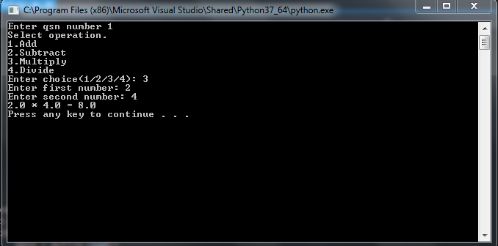

2.

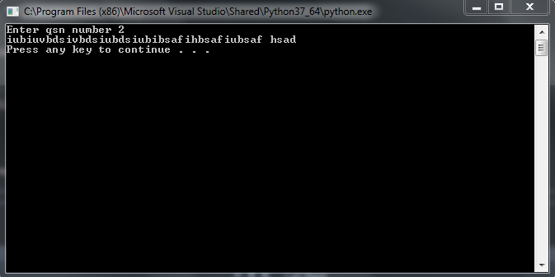

3.

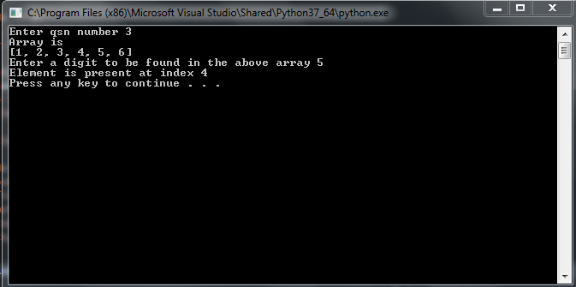

4.

